
Edith Cowan University
School of Engineering
ENS6160 Signals and Systems

Lab Report 1
Spectral Analysis of Periodic Signals

Submiited by: Anandhu Kaithavalappil Binod
Student ID: 10730544
Date of Submission: 04 October 20026

Table of Contents,Figures and list of table
Aim: 2
Objectives 3
1. Introduction 3
2. Methodology 3
3. Results and Analysis 3
A. Sinusoidal Signal 3
Spectral Analysis of Sinusoidal Signal 3
Figure 1. Theoretical time-domain representation of the 1 MHz sinusoidal signal. 4
Figure 2. Theoretical magnitude spectrum of the sinusoidal signal. 5
1.Table A 1. Sinusoidal Wave – Theoretical vs Measured Values 5
Figure 3. FFT spectrum of the sinusoidal signal displayed on the oscilloscope. 6
B. Square Wave Signal 6
Figure 4. Time-domain graph of the 1 MHz square wave signal. 7
Table B. Theoretical values of the magnitude spectrum 8
Figure 5 . Magnitude spectrum of the 1 MHz square wave signal showing the fundamental and odd harmonic components. 9
Table B2: Square Wave – Theoretical vs Measured Values 9
Figure 6. Magnitude spectrum of the 1 MHz square wave based on the measured values. 10
C. Triangular Wave Signal 11
Figure 7. Time-domain graph of the 1 MHz Triangular wave signal. 11
Figure 8. Magnitude spectrum of the triangular wave based on the theoretical values. 15
. 15
Table C: Triangular Wave – Theoretical vs Measured Values 16
Figure9.Magnitude spectrum of the triangular wave based on the measured FFT values 16
Conclusion 17
References 17

Aim:
To compare the frequency spectra of sinusoidal, square and triangular periodic signals by Fourier-series analysis and FFT measurements from oscilloscope.

Objectives
- To analyse sinusoidal, square and triangular signals in time and frequency domain.
- To calculate their theoretical spectra with Fourier series.
- To determine the spectra from the Oscilloscope FFT and compare them with the theoretical ones.

1. Introduction
Periodic signals can be analysed in both the time and frequency domains. A periodic signal can be expressed as a sum of sinusoidal signals whose frequency is the fundamental frequency and other frequencies known as harmonics in the Fourier series. In this experiment a sinusoidal, square and triangular signal were generated and displayed on an oscilloscope. They were transformed into their frequency spectra using the FFT function and their measured results were compared with the results of the Fourier series.

2. Methodology
A signal generator was used to create sinusoidal, square and triangular signals which were viewed on a digital oscilloscope. These signals have been initially analyzed in the time domain. The FFT function of the oscilloscope was then used to display its frequency spectrum. The primary spectral components' frequencies and magnitudes were measured and matched to the theoretical values obtained from Fourier-series analysis.

3. Results and Analysis

A. Sinusoidal Signal

Spectral Analysis of Sinusoidal Signal
The theoretical sinusoidal signal has an amplitude of 1 V and a fundamental frequency of 1 MHz.
The sinusoidal signal is represented by:
$$x\left(t\right)=\sin\left(2πf_{0}t\right)$$
where the fundamental frequency is 1 × 10⁶ Hz.
The period of the signal was calculated using:
$$T_{0}=\frac{1}{f_{0}}$$
$$T_{0}=\frac{1}{1×{10}^{6}}$$
$$T_{0}=1×{10}^{-6}\text{ s}=1 μ\text{s}$$
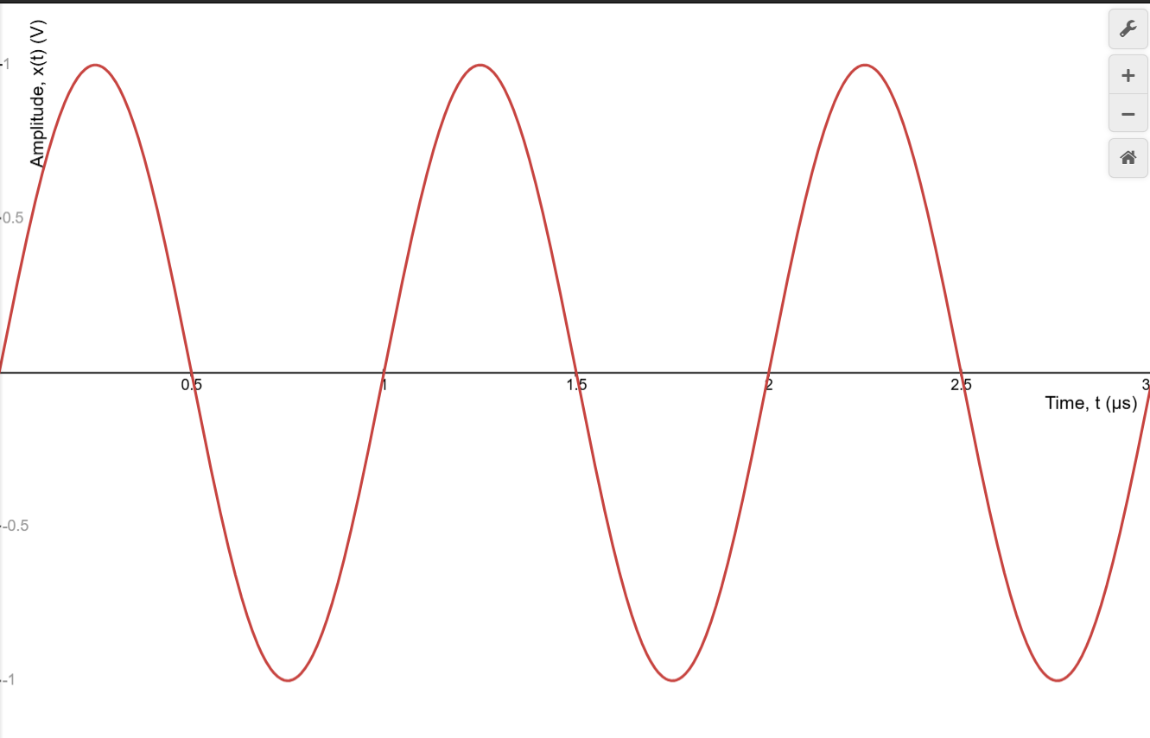

Figure 1. Theoretical time-domain representation of the 1 MHz sinusoidal signal.
Fourier-Series Coefficients
For a sinusoidal signal:
$$x\left(t\right)=\sin\left(2πf_{0}t\right)$$
Therefore, the Fourier-series coefficients are:
a₀ = 0 , aₙ = 0, b₁ = 1, and bₙ = 0 for n ≥ 2.
The magnitude of the fundamental component is:
$$A_{1}=\sqrt{a_{1}^{2}+b_{1}^{2}}$$
$$A_{1}=\sqrt{0^{2}+1^{2}}$$
$$A_{1}=1\text{ V}$$
Therefore, the theoretical spectrum contains a single frequency component at 1 MHz with a magnitude of 1 V.
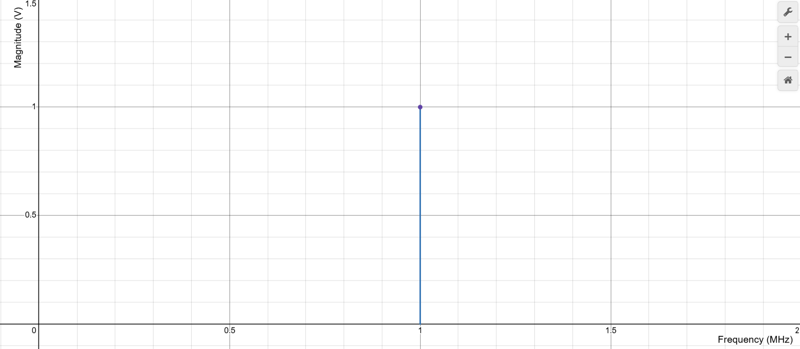

Figure 2. Theoretical magnitude spectrum of the sinusoidal signal.

Experimental Results – Sinusoidal Signal
The function generator was used with a sinusoidal output of 1 MHz at 2.0 Vpp for the sinusoidal signal. Waveform was displayed on oscilloscope and frequency spectrum of it was obtained by using FFT function.

1.Table A 1. Sinusoidal Wave – Theoretical vs Measured Values
Spectrum Characteristic | Theoretical Value | Measured Value
Peak amplitude | 1 V | −2.5 dBV  $V={10}^{\frac{-2.5}{20}}=0.75\text{ V}$
Frequency, $f$ | 1 × 10⁶ Hz | 1 × 10⁶ Hz

2. Sketch of Spectrum Based on Measured Values
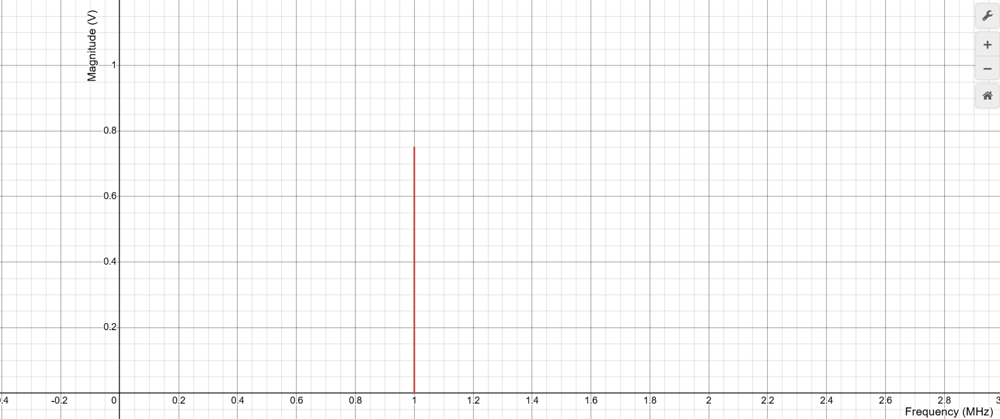

Figure 3. FFT spectrum of the sinusoidal signal displayed on the oscilloscope.

3. Comparison with the Spectrum Obtained in the Post-Lab
In the theoretical and measured spectra, both contain one frequency component at 1MHz which is the theoretical value. The theoretical value was 1 V, but the measured value was 0.75 V – 2.5 dBV. The lower measured magnitude could be from practical measurement conditions and limitations used to perform the FFT measurement.

B. Square Wave Signal
Time-Domain Graph
In a square wave, the fundamental frequency is:
$$f_{0}=1 \text{MHz}$$
Therefore, the period is:
$$T_{0}=\frac{1}{f_{0}}$$
$T_{0}=\frac{1}{1×{10}^{6}}=1 μs$
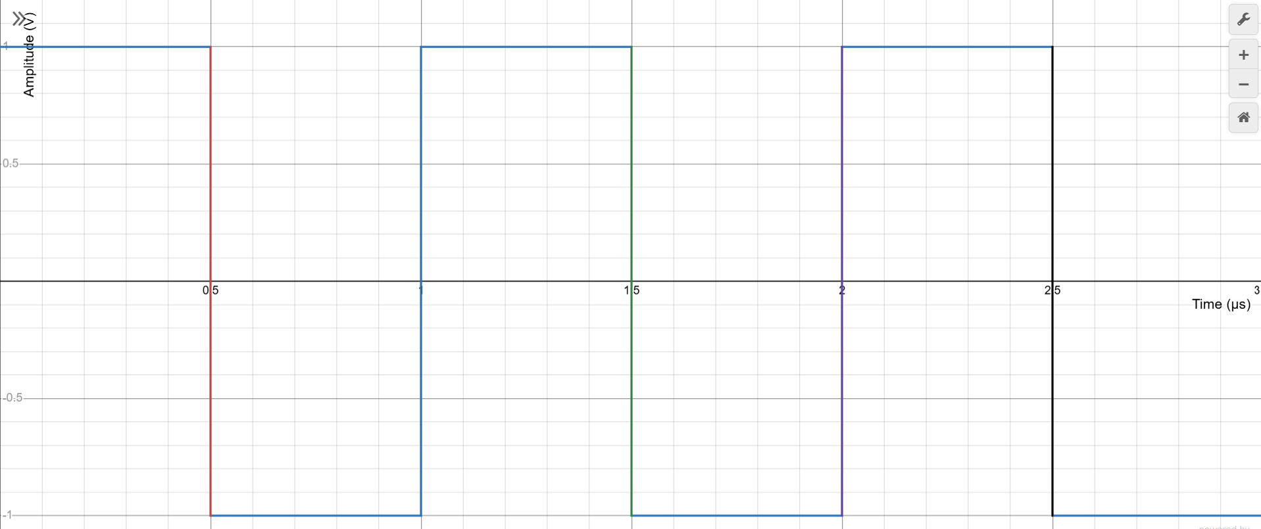

Figure 4. Time-domain graph of the 1 MHz square wave signal.

Fourier Series Coefficients
For the square wave:
$$h=1 V$$
$$f_{0}=1 MHz$$
$$a_{0}=0, a_{n}=0$$
$$b_{n}=\left\{\begin{matrix}\frac{4h}{nπ}, & n\text{ odd} \\ 0, & n\text{ even}\end{matrix}\right.$$
Since $h=1 V$
Fundamental,$n=1$:
$$b_{1}=\frac{4}{π}=1.273V$$
$$f_{1}=1f_{0}=1Mhz$$
Third harmonic, $n=3$:
$$b_{3}=\frac{4}{3π}=0.424V \\ f_{3}=3f_{0}=3Mhz$$
Fifth harmonic, $n=5$:
$$b_{5}=\frac{4}{5π}=0.255V$$
$$f_{5}=5f_{0}=5Mhz$$
Seventh harmonic,$n=7$:
$$b_{7}=\frac{4}{7π}=0.182V$$
$$f_{7}=7f_{0}=7Mhz$$
Therefore,
$$b_{1}=1.273V$$

$$b_{3}=0.424V$$

$$b_{5}=0.255V$$

$$b_{7}=0.182V$$
Theoretical Magnitude Spectrum
The theoretical magnitude spectrum of the square wave includes the fundamental frequency and the odd harmonics. The magnitude is smaller with the higher harmonics and the even harmonics are zero.

Table B. Theoretical values of the magnitude spectrum
Harmonic | Frequency | Magnitude
Fundamental, $f_{1}$ | 1 MHz | 1.273 V
3rd harmonic, $f_{3}$ | 3 MHz | 0.424 V
5th harmonic, $f_{5}$ | 5 MHz | 0.255 V
7th harmonic, $f_{7}$ | 7 MHz | 0.182 V

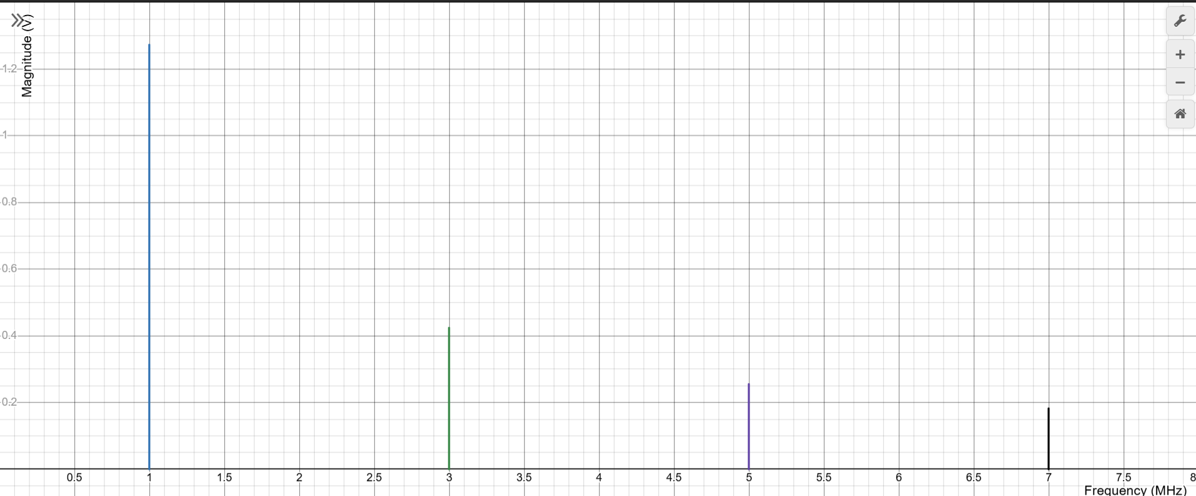

Figure 5 . Magnitude spectrum of the 1 MHz square wave signal showing the fundamental and odd harmonic components.
Experimental Results – Square Wave

Table B2: Square Wave – Theoretical vs Measured Values
Spectrum Characteristic | Theoretical Values (from post-lab) |  | Measured Values
Fundamental frequency, f₁ | 1.00 × 10⁶ Hz | 1.273V | 1.00 × 10⁶ | −6.25 mdBV
 |  |  |  | 1.413 V
3ʳᵈ harmonic, f₃ | 3.00 × 10⁶ Hz | 0.424V | 2.980 × 10⁶ | −10.156 dBV
 |  |  |  | 0.439 V
5ᵗʰ harmonic, f₅ | 5.00 × 10⁶ Hz | 0.255V | 4.980 × 10⁶ | −14.84 dBV
 |  |  |  | 0.256 V
7ᵗʰ harmonic, f₇ | 7.00 × 10⁶ Hz | 0.182V | 6.980 × 10⁶ | −17.500 dBV
 |  |  |  | 0.189 V

Magnitude Spectrum Based on Measured Values
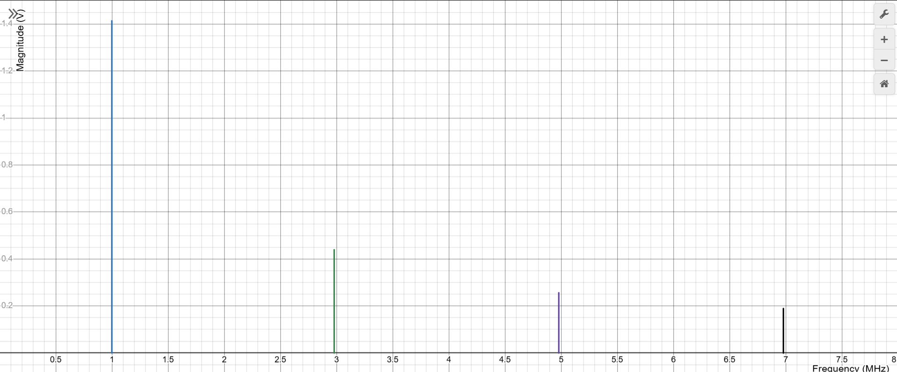

Figure 6. Magnitude spectrum of the 1 MHz square wave based on the measured values.
Comparison of Theoretical and Measured Results
The experimental spectrum was well matched with the theoretical spectrum. The measured centre frequencies 1.00 MHz, 2.98 MHz, 4.98 MHz and 6.98 MHz were found to be close to the theoretical centre frequencies 1 MHz, 3 MHz, 5 MHz and 7 MHz respectively. The even harmonics were not present in the spectrum as is theoretically expected.The odd harmonics were present and the even harmonics were not, as theoretically predicted. Theoretical and measured magnitudes showed slight differences, which can be attributed to practical measurement conditions and the limitation of the FFT measurement.

C. Triangular Wave Signal
Time-domain graph
Given:
$$A=1\text{ V}$$
$$f_{1}=200 \text{kHz}=200×{10}^{3}\text{ Hz}$$

The time period is:
$$T=\frac{1}{f_{1}}$$
$$T=\frac{1}{200×{10}^{3}}=5×{10}^{-6}\text{ s}$$
Therefore,$T=5 μs$
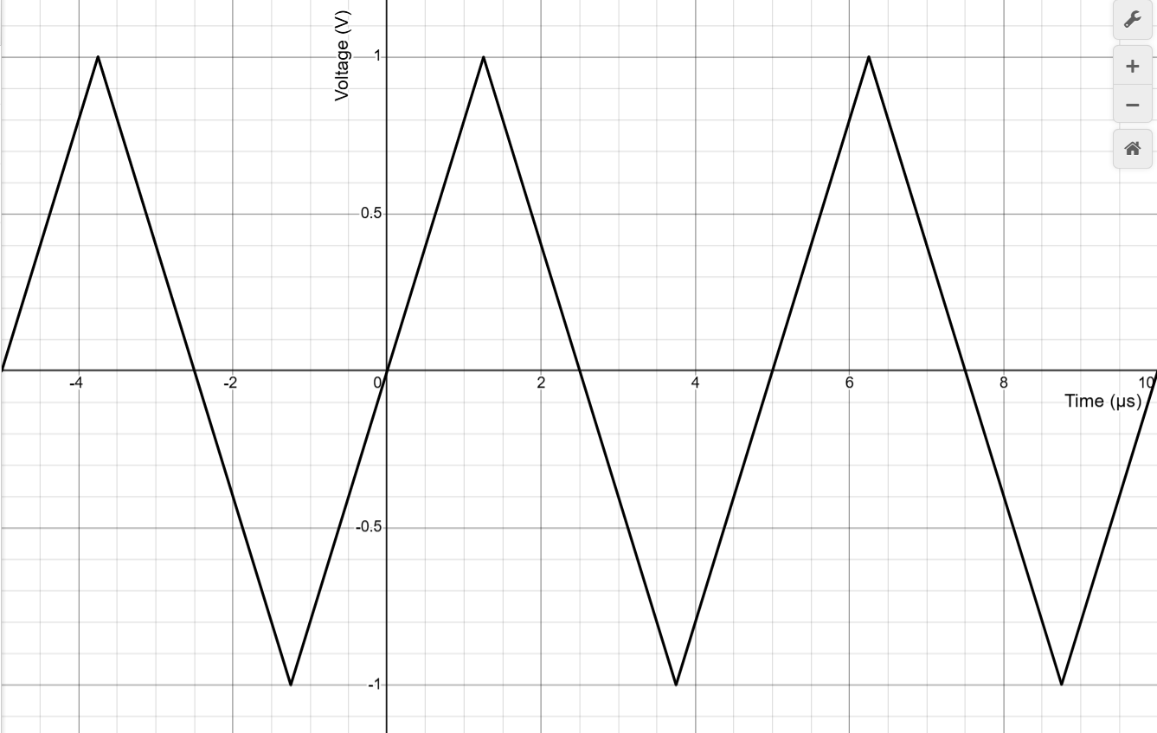

Figure 7. Time-domain graph of the 1 MHz Triangular wave signal.

Fourier Series Coefficients
For the triangular wave:
Amplitude, A = 1 V
Fundamental frequency, f₀ = 200 kHz
Period:
$$T=\frac{1}{f_{0}}$$

$$T=\frac{1}{200*{10}^{3}}$$

$$T=5 ×{10}^{-6}s$$

$$T=5 μs$$

Angular frequency:
$$ω_{0}=2πf_{0}$$

$$ω_{0}=2π\left(200×{10}^{3}\right)$$
$$ω_{0}=\frac{400000π rad}{s}$$
General Fourier series equation
$$x\left(t\right)=a_{0}+\sum_{n=1}^{∞}{\left[a_{n}cos\left(nω_{0}t\right)+b_{n}sin\left(nω_{0}t\right)\right]}$$
For this triangular wave, the waveform is odd-symmetric. Therefore:
$$a_{0}=0$$
$$a_{n}=0$$
Hence, only sine terms are present.
The Fourier coefficient for the triangular wave is:
$$b_{n}=\left[\frac{8A}{n^{2π^{2}}}\right]\sin\left(\frac{nπ}{2}\right)$$
Since A = 1 V
$$b_{n}=\left[\frac{8}{n^{2π^{2}}}\right]\sin\left(\frac{nπ}{2}\right)$$
Fundamental Harmonic, n = 1
$$b_{1}=\left[\frac{8}{1^{2π^{2}}}\right]\sin\left(\frac{π}{2}\right)$$
$$b_{1}=\frac{8}{π^{2}}$$
$$b_{1}=0.8106 V$$
Frequency:
$$f_{1}=1×f_{0}$$
$$f_{1}=1×200 kHz$$
$$f_{1}=200 kHz$$
Therefore, the fundamental component is:
$$0.8106\sin\left(ω_{0}t\right)$$
Third Harmonic, n = 3
$$b_{3}=\left[\frac{8}{3^{2π^{2}}}\right]\sin\left(\frac{3π}{2}\right)$$
$$b_{3}=-\frac{8}{9π^{2}}$$
$$b_{3}=-0.0901 V$$
Frequency:
$$f_{3}=3×f_{0}$$
$$f_{3}=3×200 kHz$$
$$f_{3}=600 kHz$$
Therefore, the third harmonic component is:
$$-0.0901\sin\left(3ω_{0}t\right)$$
Fifth Harmonic, n = 5
$$b_{5}=\left[\frac{8}{5^{2π^{2}}}\right]\sin\left(\frac{5π}{2}\right)$$
$$b_{5}=\frac{8}{25π^{2}}$$
$$b_{5}=0.0324 V$$
Frequency:
$$f_{5}=5×f_{0}$$
$$f_{5}=5×200 kHz$$
$$f_{5}=1000 kHz$$
$$f_{5}=1.0 MHz$$
Therefore, the fifth harmonic component is:
$$0.0324\sin\left(5ω_{0}t\right)$$
Seventh Harmonic, n = 7
$$b_{7}=\left[\frac{8}{7^{2π^{2}}}\right]\sin\left(\frac{7π}{2}\right)$$
$$b_{7}=-\frac{8}{49π^{2}}$$
$$b_{7}=-0.0165 V$$
Frequency:
$$f_{7}=7×f_{0}$$
$$f_{7}=7×200 kHz$$
$$f_{7}=1400 kHz$$
$$f_{7}=1.4 MHz$$
Therefore, the seventh harmonic component is:
$$-0.0165\sin\left(7ω_{0}t\right)$$
Final Fourier Series
$$x\left(t\right)=0.8106sin\left(ω_{0}t\right)-0.0901sin\left(3ω_{0}t\right)+0.0324sin\left(5ω_{0}t\right)-0.0165sin\left(7ω_{0}t\right)+…$$
$$ω_{0}=2π(200×10^3 )rad/s$$
$$ω_{0}=400000π rad/s$$
$$\left|b_{1}\right|=0.8106 V$$
$$\left|b_{3}\right|=0.0901 V$$
$$\left|b_{5}\right|=0.0324 V$$
$$\left|b_{7}\right|=0.0165 V$$
Magnitude Spectrum – Plot and Description
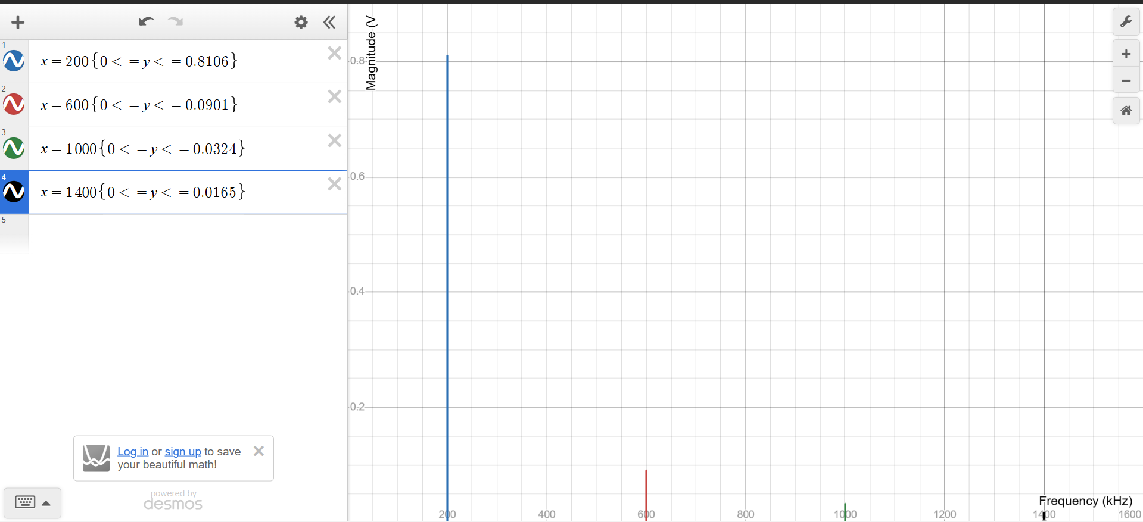

Figure 8. Magnitude spectrum of the triangular wave based on the theoretical values.

.

Only odd harmonics are present in the magnitude spectrum of the triangular wave. The harmonics are 200 kHz, 600 kHz, 1.0 MHz and 1.4 MHz for the fundamental, the 3rd, 5th and 7th harmonics, respectively. It is observed that the amplitude of harmonics falls off steeply with the harmonic order in line with Fourier series of a triangular wave.That completes the post-lab theoretical section for the triangular wave.

Table C: Triangular Wave – Theoretical vs Measured Values

Spectrum Characteristic | Theoretical Values (from post-lab) |  | Measured Values
Fundamental frequency, f₁ | 200 kHz | 0.8106 V | 200 kHz | -4.687 dBV
 |  |  |  | 0.583 V
3ʳᵈ harmonic, f₃ | 600 kHz | 0.0901 V | 596 kHz | -23.437 dBV
 |  |  |  | 0.0673 V
5ᵗʰ harmonic, f₅ | 1.00 MHz | 0.0324 V | 998 kHz | -32.187 dBV
 |  |  |  | 0.0246 V
7ᵗʰ harmonic, f₇ | 1.40 MHz | 0.0165 V | 1.40 MHz | -37.8125 dBV
 |  |  |  | 0.0129 V

Magnitude spectrum – Plot and description of measured FFT values.

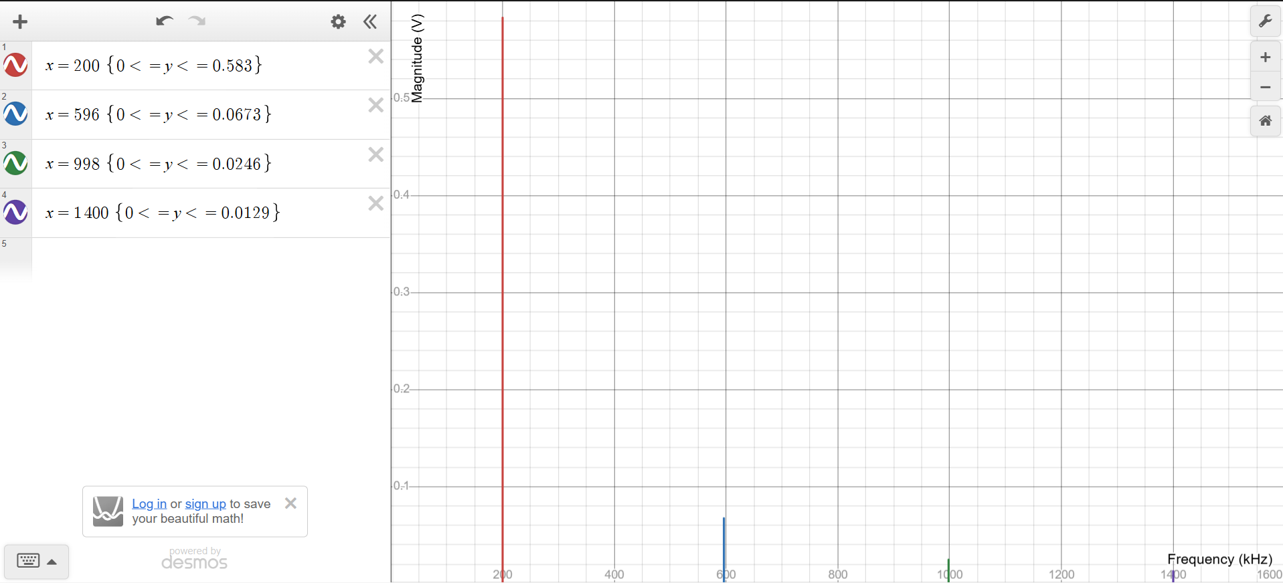

Figure9.Magnitude spectrum of the triangular wave based on the measured FFT values

The measured spectrum includes the fundamental and the odd harmonics at 200 kHz, 596 kHz, 998 kHz, and 1.40 MHz. As the harmonic order increases, the magnitude of the harmonic decreases quickly, as it should for a triangular form.
Comparison of Theoretical and Measured Results

The measured triangular wave spectrum revealed frequencies at about 200kHz, 596kHz, 998kHz and 1.40MHz, which are fundamental, 3rd, 5th and 7th harmonics, respectively. The measured frequencies were approximately 200 kHz, 600 kHz, 1.00 MHz and 1.40 MHz, which are the theoretical frequencies. The measured values also quickly diminished as harmonic number increased, as would be expected for a triangular wave. It is noted that the difference between the theoretical and measured magnitudes are small, which may be due to the practical measurement condition, as well as the limitations of the oscilloscope FFT function.

Conclusion
Using Fourier-series theory and oscilloscope FFT measurements, the spectral characteristics of sinusoidal, square and triangular periodic signals were analysed. The fundamental frequency was the dominant component with the sinusoidal signal, and the fundamental and odd components were present in the square wave, but with decreasing amplitudes. The triangular wave did have odd harmonics as well, but they became much smaller as the order of the harmonic increased. The FFT frequencies measured were generally near the harmonic frequencies for all three waveforms. The differences in the magnitude between the theory and the measurement were observed to be small, and this difference can be explained by the practical measurement conditions and the limitation of the FFT measurement. Overall, the experimental results verified the expected Fourier-series behaviour of the three periodic signals.

References
1.Lundheim, L. (2021). The role of Fourier series in mathematics and in signal theory. International Journal of Research in Undergraduate Mathematics Education, 7, 633–651. https://doi.org/10.1007/s40753-021-00134-z
2. Wang, Y., He, Z., & Zi, Y. (2013). Multiple harmonics fitting algorithms applied to periodic signals based on Hilbert–Huang transform. Journal of Sensors, 2013, Article 580152. https://doi.org/10.1155/2013/580152

